Outdoor Solar Spot Light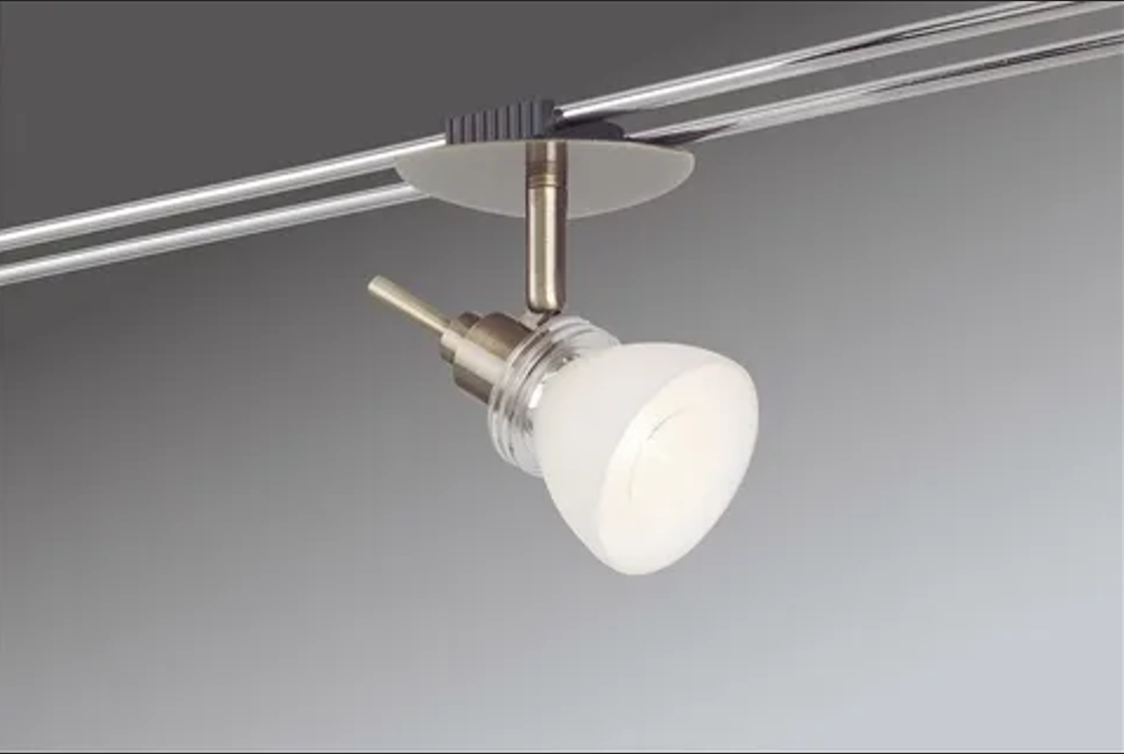

#### ****Description:****

**Outdoor Solar Spot Lights** are eco-friendly, energy-efficient lighting solutions designed to illuminate your outdoor spaces using solar power. These lights are perfect for highlighting garden features, pathways, driveways, and outdoor decor. With built-in solar panels and rechargeable batteries, Outdoor Solar Spot Lights provide bright, reliable lighting without the need for electrical wiring.

* **Technology:** Solar-powered LED.
* **Power Source:** Built-in solar panel and rechargeable battery.
* **Bulb Type:** Integrated LED (non-replaceable).
* **Wattage:** 2W (equivalent to 20W incandescent).
* **Lumens:** 200 lumens.
* **Color Temperature:** 3000K (warm white), 4000K (cool white).
* **Dimmable:** No.
* **Lifespan:** 50,000 hours.
* **Energy Efficiency:** 100% solar-powered, no electricity required.
* **Weather Resistance:** IP65 rated (dust-tight and protected against water jets).

#### ****Key Features:****

* **Solar-Powered:** Charges during the day and automatically turns on at night.
* **Energy-Efficient:** Uses solar energy, reducing electricity costs.
* **Easy Installation:** No wiring required; simply stake into the ground.
* **Weather-Resistant:** Designed to withstand rain, snow, and extreme temperatures.
* **Adjustable Heads:** Allows you to direct light precisely where it’s needed.
* **Automatic On/Off:** Built-in light sensor turns the lights on at dusk and off at dawn.
* **Long Lifespan:** Lasts up to 50,000 hours, reducing the need for frequent replacements.

#### ****Pricing:****

* **Single Solar Spotlight:** $19.99
* **2-Pack:** 34.99(34.99(17.50 per light)
* **4-Pack:** 59.99(59.99(15.00 per light)

#### ****Where to Use:****

* **Gardens:** Highlight plants, trees, and garden features.
* **Pathways:** Illuminate walkways for safety and visibility.
* **Driveways:** Provide bright lighting for driveways and entrances.
* **Outdoor Decor:** Accentuate statues, fountains, and other outdoor decor.
* **Patios:** Create a cozy ambiance for outdoor gatherings.

### ****Customer Reviews:****

* ⭐⭐⭐⭐⭐ "These Outdoor Solar Spot Lights are amazing! They provide bright, focused light, and the solar power feature is a game-changer. No more worrying about wiring or electricity bills!" – Sarah L.
* ⭐⭐⭐⭐ "Great value for the price. The lights are bright, and the installation was super easy. Highly recommend for anyone looking to upgrade their outdoor lighting." – James T.
* ⭐⭐⭐⭐⭐ "I love how eco-friendly these spotlights are. The adjustable heads make it easy to direct the light exactly where I need it." – Emily R.

### ****How to Order:****

1. Visit our website: [www.brightworldlighting.com](http://www.brightworldlighting.com/)
2. Select your preferred pack size (Single, 2-Pack, or 4-Pack).
3. Add to cart and proceed to checkout.
4. Enjoy free shipping on all orders over $50!

### ****Warranty and Support:****

* **Warranty:** 2-year limited warranty covering manufacturing defects.
* **Customer Support:** Contact us at [support@brightworldlighting.com](mailto:support@brightworldlighting.com) or call +1-800-123-4567 for assistance.

### ****Visual Representation:****

Include high-quality images of the Outdoor Solar Spot Lights in different settings (e.g., garden, pathway) to showcase their versatility and design.